
LA GRANDEE INTERNATIONAL COLLEGE
Simalchaur, Pokhara, Nepal

A Project Proposal
on
StockEase

Submitted to
La Grandee International College
Bachelor of Computer Application (BCA) Program

In partial fulfillment of the requirements for the degree of BCA under
Pokhara University

Submitted by
Name | Program/Semester | PU-REGISTRATION NO
Yubaraj Pandey | BCA 6th SEM | 2021-1-53-0373
Pawan Poudel | BCA 6th SEM | 2021-1-53-0357

Date: 1/10/2024

Table of Contents
List of Figures iii
1. Introduction 1
2. Problem Statement 2
3. Objectives 3
4. Background Study 4
5. Methodology 5
6. Project Gantt Chart 6
7. Deliverables 7
8. References 8

List of Figures
Fig 5. 1: Agile Methodology 5
Fig 6. 1: Project Gantt Chart 7

Introduction
StockEase is an all-in-one solution designed to streamline stock and inventory management for businesses of all sizes. Whether you're managing a small retail store, a large warehouse, or an e-commerce platform, the platform provides real-time insights into stock levels, minimizing the risk of overstocking or running out of key products. Its user-friendly interface allows for smooth navigation through intuitive search filters, enabling precise tracking based on product category, location, quantity, and stock status.
StockEase is a web-based application that allows users to efficiently manage inventory based on their business needs. It also provides suppliers with an easy-to-use platform for uploading and managing their product listings. Users can easily filter inventory details and track stock movements, helping them make informed decisions about replenishing stock or managing surplus. Whether you're overseeing raw materials for manufacturing or managing finished goods in retail, StockEase ensures complete transparency in stock levels, sales performance, and order fulfillment.
The platform’s motto, “Optimize Your Inventory, Maximize Your Efficiency,” reflects its commitment to reducing manual errors, improving accuracy, and saving time. With real-time data and secure messaging, StockEase connects businesses with suppliers, simplifying the ordering process while allowing users to analyze price trends and negotiate deals. By offering complete transparency and automating repetitive tasks, StockEase saves valuable time for managers and suppliers alike, ensuring smooth operations across the supply chain.

Problem Statement
Managing inventory using traditional or outdated systems is becoming an increasingly challenging task for businesses today. The inefficiencies and limitations of current inventory management systems not only disrupt daily operations but also affect long-term growth and customer satisfaction. From delayed stock updates to lack of integration, the shortcomings of these systems create bottlenecks across various functions. The following are some of the key issues experienced by users:
- Current inventory management systems suffer from inaccurate stock tracking, manual data entry errors, lack of visibility across locations, slow order fulfillment, limited reporting capabilities, and poor system integration, leading to operational inefficiencies and reduced customer satisfaction.

Objectives
In the current digital landscape, businesses are increasingly turning to computerized solutions to enhance efficiency and streamline operations. An "Inventory Management System" is designed to meet this demand, providing various features that help improve business performance and optimize daily operations. Built to address key challenges, the main objective of this project is:
- Real-time stock tracking and order processing to streamline operations and reduce delays.
- Supplier management and financial monitoring to enable data-driven decision-making and improve accuracy.

Background Study
Inventory management has long been a critical function in businesses, playing a central role in ensuring that the products are available at the right time and in the right quantity. As technology has advanced, inventory systems have evolved from manual processes to highly sophisticated solutions. IMS Software by IMS Group in Nepal exemplifies this evolution by offering comprehensive tools tailored for businesses in diverse industries, including retail, hospitality, and manufacturing.
The evolution of technology introduced computerized inventory management systems, which offered significant improvements over manual methods. Early systems were primarily used by large-scale businesses to track stock levels, automate reordering processes, and reduce excess inventory. Over time, the adoption of inventory management systems expanded across industries, from retail and manufacturing to healthcare and hospitality, as more businesses recognized the need for precise inventory control to stay competitive.
Modern inventory management systems offer a wide range of features, such as real-time stock tracking, integration with sales and procurement systems, barcode and RFID scanning, and predictive analytics. These systems enable businesses to maintain optimal stock levels, reduce waste, and improve order fulfillment processes. Cloud-based solutions and mobile applications have further enhanced accessibility and ease of use, allowing businesses to manage their inventory from anywhere with real-time updates.
As businesses continue to face challenges such as fluctuating demand, supply chain disruptions, and changing customer expectations, the role of a robust inventory management system becomes even more crucial. An effective system helps businesses minimize stockouts, optimize warehouse operations, and provide accurate data for better decision-making, ultimately leading to improved customer satisfaction and increased profitability.

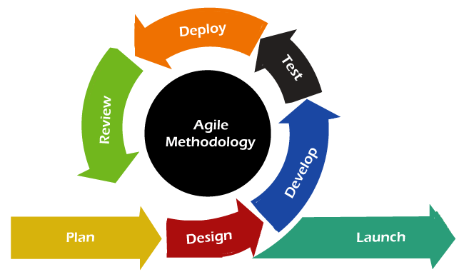
Methodology
Fig 5. 1: Agile Methodology

We are employing the Agile Methodology as our chosen approach for project development. This model follows an iterative process that emphasizes flexibility, collaboration, and continuous improvement. Agile is divided into short development cycles called sprints, which typically last 1-4 weeks. Each sprint involves planning, development, testing, and review, allowing teams to deliver incremental updates to the project.
In Agile, development is adaptive, with the ability to respond to feedback and changing requirements, promoting a collaborative environment between stakeholders and the development team. This iterative approach helps us remain flexible, deliver functional components quickly, and ensure that the final product evolves according to customer needs.

Project Gantt Chart

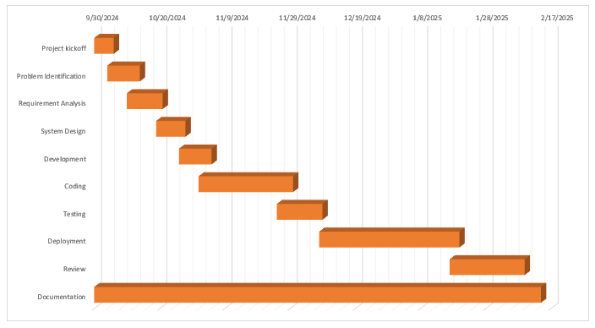
Fig 6. 1: Project Gantt Chart

Deliverables
After StockEase is created, there are certain expectations it must meet for it to be considered successful. While it may not address every single need, there are key deliverables that should be fulfilled:
- Fully functional inventory management platform accessible across desktop and mobile devices.
- User-friendly interface with intuitive filters for tracking stock, suppliers, and order status.
- Real-time updates for stock levels to ensure accurate and up-to-date inventory data.
- Streamlined order processing and fulfillment, facilitating tracking, notifications, and supplier management within the platform.

References
(n.d.). Retrieved from https://www.unleashedsoftware.com/inventory-management-guide/inventory-management-systems/

